Software Requirements Specification

Version 1.0

Thegioididong Store

GROUP 5

HCM22_CPL_JAVA_02

# **Table of Contents**

Table of Contents **1**

**1.0. Introduction** **2**

1.1. Purpose 2

1.2. Scope of Project 2

1.3. Glossary 2

2.0. Overall Description **2**

2.1 System Environment 2

2.2 Functional Requirements Specification 3

2.2.1. Thegioididong Admin Use Case 3

Use case: Delete a specific promotion 8

Use case: View Order List 9

Use case: View Order Detail 10

Use case: Update Order Detail 10

Use case: Delete order detail 11

Use case: View customer list 12

Use case: View a specific customer 12

Use case: Edit a specific customer 13

2.2.2 Thegioididong Customer Use Case 16

2.3 User Characteristics 22

2.4 Non-Functional Requirements 22

**3.0. Requirements Specification** **23**

3.1 External Interface Requirements 23

3.2 Functional Requirements 23

3.3 Detailed Non-Functional Requirements 25

3.3.1 Logical Structure of the Data 25

3.3.2 Security 25

Performance 25

# **1.0. Introduction**

## ***1.1. Purpose***

The purpose of this document is to present a detailed description of the Thegioididong Store System . It will explain the purpose and features of the system, the interfaces of the system, what the system will do, the constraints under which it must operate and how the system will react to external stimuli. This document is intended for both the stakeholders and the developers of the system and will be proposed to the potential clients for its approval.

## ***1.2. Scope of Project***

This software product will be the website for buyer and the manager thegioididong store.

## ***1.3. Glossary***

| **Term** | **Definition** |
| --- | --- |
| Administrator | Users could login to update data |
| Customer | Users want to find and buy items |
| Member | Customers have bought any item in store or Customer want to register their information to shopping in store |

## 

# **2.0. Overall Description**

## ***2.1 System Environment***

End users could be project managers, quality assurance team and other project members. There are more than 500 possible users.

TBD

## ***2.2 Functional Requirements Specification***

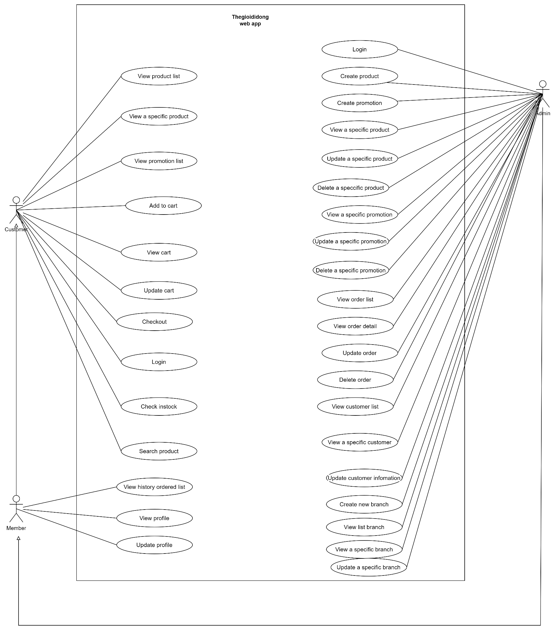

**Figure 1 – Thegioididong Store System Use Case**

This section outlines the use cases for each of the active user separately.

### 

### **2.2.1. Thegioididong Admin Use Case**

Use case : **Admin Login**

**Diagram :**



**Brief Description**

The admin accesses the Thegioididong website to login.

**Initial Step-By-Step Description**

Before this use case can be initiated, the user has already accessed the login page on Thegioididong website.

1. The admin accesses the login page.

2. The admin fills username/password.

3. The system validates input and response error message if error happened.

4. The system redirect to add product page if correct username/password.

5. The system allows the user to perform other activities.

Use case : **Admin Add New Product**

**Brief Description**

The admin accesses the Thegioididong website to add new product.

**Initial Step-By-Step Description**

Before this use case can be initiated, the user has already accessed the Thegioididong website with role admin.

1. The admin accesses to add product page.

2. The admin fills new product information and click add product.

3. The system insert new product to database and clear form.

4. The system allows the admin to perform other activities.

Use case : **Admin Add New Promotion**



**Brief Description**

The admin accesses the Thegioididong website to add new promotion.

**Initial Step-By-Step Description**

Before this use case can be initiated, the user has already accessed the Thegioididong website with role admin.

1. The admin accesses to add product page.

2. The admin fills new promotion information and click add promotion.

3. The system insert new promotion to database and clear form.

4. The system allows the admin to perform other activities.

Use case : **Admin View Detail Product**

**Diagram :**



**Brief Description**

The admin accesses the Thegioididong website to view detail product.

**Use Case:** Update a specific product

**Diagram:**

**Brief Description**

Admin accesses the Thegioididong to update a specific product.

**Initial Step-By-Step Description**

Admin need to login to use this function

1. Admin accesses the home page.

2. System redirects to list all products.

3. Admin clicks on a specific product.

4. System redirects to product details page.

5. System shows product details.

6. Admin can edit product’s information.

7. Admin clicks “Lưu”.

8. System update information in database.

9. System return to home page.

Use Case: **Delete a specific product**

**Diagram:**

**Brief Description**

Admin accesses the Thegioididong to delete a specific product.

**Initial Step-By-Step Description**

Admin need to login to use this function

1. Admin accesses the home page.

2. System redirects to list all products.

3. Admin clicks “Xóa” button on a specific product.

4. System redirects to confirm page.

5. Admin clicks “Đồng ý”.

6. System update information in database.

7. System return to home page.

Use Case: **Update a specific promotion**

**Diagram:**

**Brief Description**

Admin accesses the Thegioididong to Apply discount of group of product.

**Initial Step-By-Step Description**

Admin need to login to use this function

1. Admin accesses the home page.

2. The system redirects to a list of all products.

3. Admin clicks “Thêm giảm giá” on top right.

4. Admin chooses the category of product.

5. Admin input discount value.

6. Admin clicks “Lưu”.

7. System update information in database.

8. System returns to home page.

Use Case: **View a specific promotion**

**Diagram:**

**Brief Description**

Admin accesses the Thegioididong to View a specific promotion.

**Initial Step-By-Step Description**

Admin need to login to use this function

1. Admin accesses the home page.

2. The system redirects to list all products.

3. Admin input category in search bar.

4. Admin clicks “Tìm kiếm”.

5. System show list of promotion have similar name to category.

6. Admin clicks on a specific promotion.

7. System show promotion details.

**Initial Step-By-Step Description**

Before this use case can be initiated, the user has already accessed the Thegioididong website with role admin.

1. The admin accesses to view detail product.
2. The system allows the admin to perform other activities .

#### 

#### Use case: Delete a specific promotion

**Diagram:**



**Brief Description**

The admin accesses the Thegioididong to delete the promotion.

**Initial Step-By-Step Description**

Before this use case can be initiated, the admin has already accessed the Thegioididong website with the role admin.

1. The customer accesses the admin page.
2. The system redirects to list all promotions.
3. The admin clicks view promotion on the promotion page.
4. The system shows all selected promotions.
5. The admin can remove each promotion on the promotion list page.
6. The system allows the admin to perform other activities.

#### Use case: View Order List

**Diagram:**



**Brief Description**

The admin accesses the Thegioididong to view the order list.

**Initial Step-By-Step Description**

Before this use case can be initiated, the admin has already accessed the Thegioididong website with the role admin.

1. The admin accesses the admin page.
2. The system redirects to list all order information.
3. The customer clicks view order list.
4. The system shows all selected orders.
5. The system allows the admin to perform other activities.

#### Use case: View Order Detail

**Diagram:**



**Brief Description**

The admin accesses the Thegioididong to view the order list.

**Initial Step-By-Step Description**

Before this use case can be initiated, the admin has already accessed the Thegioididong website with the role admin.

1. The admin accesses the admin page.
2. The system redirects to list all order information.
3. The admin clicks view order list.
4. The system shows all selected orders.
5. The admin clicks view order detail of the order in order page.
6. The system redirects to the order detail page of the order
7. The system allows the admin to perform other activities.

#### Use case: Update Order Detail

**Diagram:**



**Brief Description**

The admin accesses the Thegioididong to view the order list.

**Initial Step-By-Step Description**

Before this use case can be initiated, the admin has already accessed the Thegioididong website with the role admin.

1. The admin accesses the admin page.
2. The system redirects to list all order information.
3. The admin clicks view order list.
4. The system shows all selected orders.
5. The admin clicks view order detail of the order in order page.
6. The system redirects to the order detail page of the order
7. The admin can update or edit the information of order in order/order detail page
8. The system allows the admin to perform other activities.

#### Use case: Delete order detail

**Diagram:**



**Brief Description**

The admin accesses the Thegioididong to delete order detail.

**Initial Step-By-Step Description**

Before this use case can be initiated, the admin has already accessed the Thegioididong website with the role admin.

1. The customer accesses the admin page.
2. The system redirects to list all order detail.
3. The admin clicks view order detail on the order page.
4. The system shows all selected orders detail.
5. The admin clicks view order detail of the order in order page.
6. The system redirects to the order detail page of the order
7. The admin can delete or edit the information of order in order/order detail page
8. The system allows the admin to perform other activities.

#### Use case: View customer list

**Diagram:**



**Brief Description**

The admin accesses the Thegioididong to view the customer list.

**Initial Step-By-Step Description**

Before this use case can be initiated, the admin has already accessed the Thegioididong website with the role admin.

1. The admin accesses the admin page.
2. The system redirects to list all customer information.
3. The customer clicks view customer list.
4. The system shows all selected customers.
5. The system allows the admin to perform other activities.

#### Use case: View a specific customer

**Diagram:**



**Brief Description**

The admin accesses the Thegioididong to view the customer list.

**Initial Step-By-Step Description**

Before this use case can be initiated, the admin has already accessed the Thegioididong website with the role admin.

1. The admin accesses the admin page.
2. The system redirects to list all customer information.
3. The admin clicks view customer list.
4. The system shows all selected customers.
5. The system allows the admin to perform other activities.

#### Use case: Edit a specific customer

**Diagram:**



**Brief Description**

The admin accesses the Thegioididong to edit the customer.

**Initial Step-By-Step Description**

Before this use case can be initiated, the admin has already accessed the Thegioididong website with the role admin.

1. The admin accesses the admin page.
2. The system redirects to list all customer information.
3. The admin clicks view customer list.
4. The system shows all selected customers.
5. The admin clicks view a specific customer in customer page.
6. The admin can edit the information of customer in customer page.
7. The system allows the admin to perform other activities.

Use case: **Create New Branch**

**Diagram:**

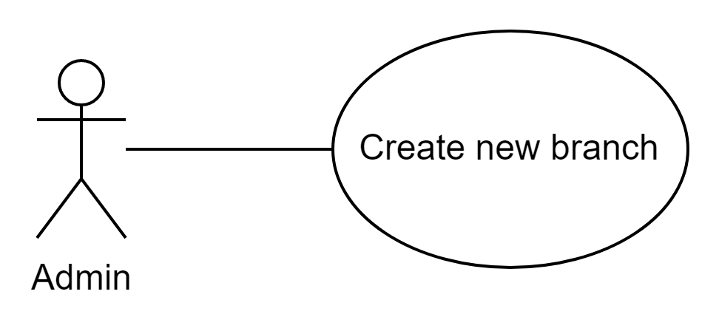

**Brief Description**

Before this use case can be initiated, the admin has already accessed the Thegioididong website with the role admin.

**Initial Step-By-Step Description**

The admin accesses the Thegioididong to create new branch

1. The admin accesses the admin page.
2. The system redirects to list branch page
3. The admin click create new branch
4. The admin fill in the form with all valid information of a new branch
5. The admin click Save button
6. The system redirect admin to list all branch page
7. The system allows the admin to perform other activities.

Use case: **View list branch**

**Diagram:**

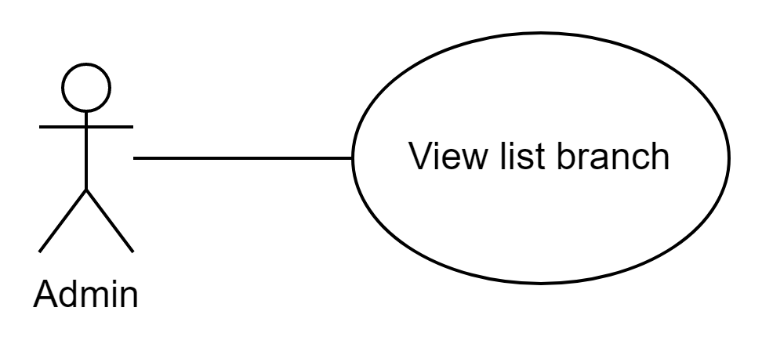

**Brief Description**

Before this use case can be initiated, the admin has already accessed the Thegioididong website with the role admin.

**Initial Step-By-Step Description**

The admin accesses the Thegioididong to view list branch

1. The admin accesses the admin page.
2. The admin click on the Branch tab on the menu
3. The system redirect admin to list all branch page
4. The system allows the admin to perform other activities.

Use case: **View a specific branch**

**Diagram:**

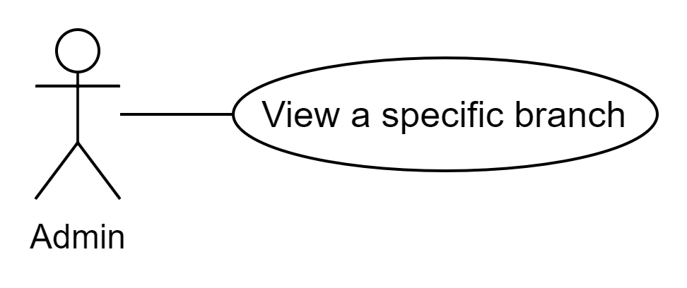

**Brief Description**

Before this use case can be initiated, the admin has already accessed the Thegioididong website with the role admin.

**Initial Step-By-Step Description**

The admin accesses the Thegioididong to view a specific branch

1. The admin accesses the admin page.
2. The admin click on the Branch tab on the menu
3. The system redirect admin to list all branch page
4. The admin click on an item in the list branch to view
5. The system redirect admin to a page contains information of this branch
6. The system allows the admin to update information and perform other activities.

Use case: **Update a specific branch**

**Diagram:**

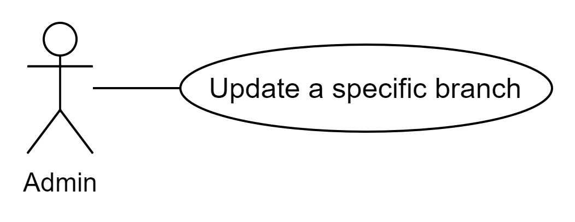

**Brief Description**

Before this use case can be initiated, the admin has already accessed the Thegioididong website with the role admin.

**Initial Step-By-Step Description**

The admin accesses the Thegioididong to update a specific branch

1. The admin accesses the admin page.
2. The admin click on the Branch tab on the menu
3. The system redirect admin to list all branch page
4. The admin click on the branch item in the list branch to edit
5. The admin can update the branch information and click on Save button
6. The system redirects the admin to the branch page that has just been updated.
7. The system allows the admin to perform other activities.

### 

### 2.2.2. Thegioididong Customer Use Case

Use case : **View Product List**

**Diagram :**

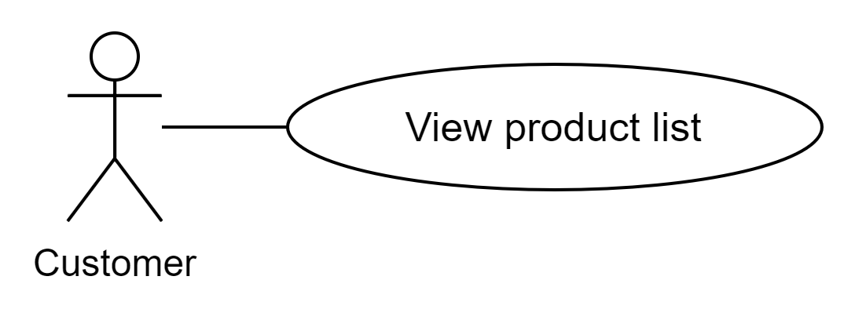

**Brief Description**

Customer accesses the Thegioididong website and see product list.

**Initial Step-By-Step Description**

Before this use case can be initiated, the Customer has already accessed the view page on Thegioididong website.

1. The system get all products in stock.

2. The system show all products in stock to view page .

Use case : **Customer View A Specific Product**

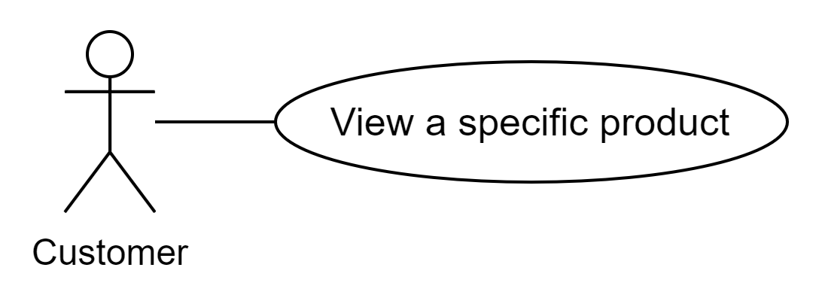

**Brief Description**

Customer accesses the Thegioididong website and choose specific product.

**Initial Step-By-Step Description**

Before this use case can be initiated, view product list function must initial and the Customer accesses to products view page of thegioididong website..

1. The Customer chooses one product.

2. The system gets specific information of that product.

3. The system shows product information to specific product view page.

Use case : **Customer View Promotion List**

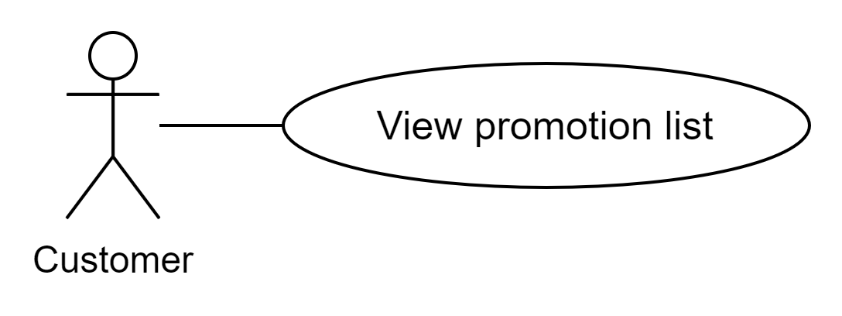

**Brief Description**

Customer accesses the Thegioididong website to see sale products.

**Initial Step-By-Step Description**

Before this use case can be initiated, view product list function must initial.and the user accesses to products view page of thegioididong website..

1. The system get all products have promotion.

2. The system show all products have promotion to products view page.

Use case : **Customer Add To Cart**

**Diagram :**

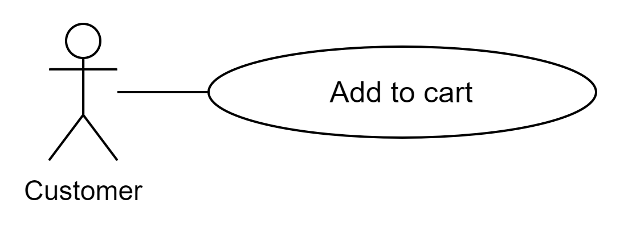

**Brief Description**

The Customer accesses the Thegioididong website to order product.

**Initial Step-By-Step Description**

Before this use case can be initiated, view product list function must initial.and view specific product initial and the user accesses to specific product view page of thegioididong website.

1. The Customer accesses to view product list page.
2. The Customer accesses to view specific product view page.
3. The Customer choose buy now to order product.
4. The system get specific product information add to cart.

**Use Case:** Customer View Cart

**Diagram:**

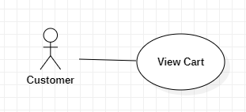

**Brief Description**

The customer accesses the Thegioididong to view cart.

**Initial Step-By-Step Description**

Customers don’t need to login to use this function

1. The customer accesses the home page.
2. The system redirects to list all products.
3. The customer clicks view cart on top right.
4. The system redirects to cart page.
5. The system allows the user to perform other activities.

**Use Case:** Customer Update Cart

**Diagram:**

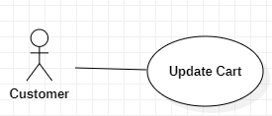

**Brief Description**

The customer accesses the Thegioididong to update cart.

**Initial Step-By-Step Description**

Customers don’t need to login to use this function

1. The customer accesses the home page.

2. The system redirects to list all products.

3. The customer clicks view cart on top right.

4. The system redirects to cart page.

5. The system shows all selected products.

6. The customer can removes each cart item.

7. The system allows the user to perform other activities.

**Use Case:** Customer Check out

**Diagram:**

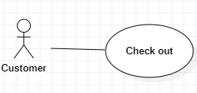

**Brief Description**

The customer accesses the Thegioididong to check out.

**Initial Step-By-Step Description**

Customers don’t need to login to use this function

1. The customer accesses the home page.
2. The system redirects to list all products.
3. The customer clicks view cart on top right.
4. The system redirects to cart page.
5. The system shows all selected products.
6. The customer fills in all the boxes.
7. The customer clicks “Đặt hàng” .
8. The system redirects to payment page.
9. The customer chooses the payment method and clicks “Xác nhận”.
10. The system stores the information to Database.
11. The customer also can cancel the order by clicking “Hủy”.
12. The system returns to cart page.

**Use Case:** Customer Log in

**Diagram:**

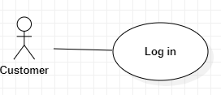

**Brief Description**

The customer accesses the Thegioididong to log in.

**Initial Step-By-Step Description**

1. The customer accesses the home page.
2. The system redirects to list all products.

3. The customer clicks “Lịch sử đơn hàng”.

4. The system redirects to Login-page.

5. The customer fills in the phone number box, clicking “Tiếp tục”.

6. The system will send an OTP code to authenticate the customer.

7. The customer types the OPT code to log in.

**Use Case:** Customer search product

**Diagram:**

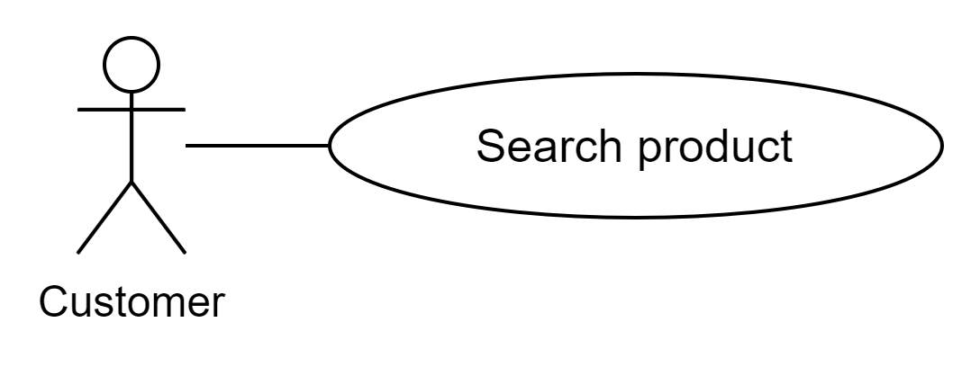

**Brief Description**

The customer accesses the Thegioididong to search product.

**Initial Step-By-Step Description**

1. The customer accesses the home page.
2. The customer fills in the search box the product that the customer wants to find
3. The system redirects to a result set of search
4. The system allows the customer to perform other activities.

### **2.2.3. Thegioididong Member Use Case**

**Use Case:** View history ordered list

**Diagram:**

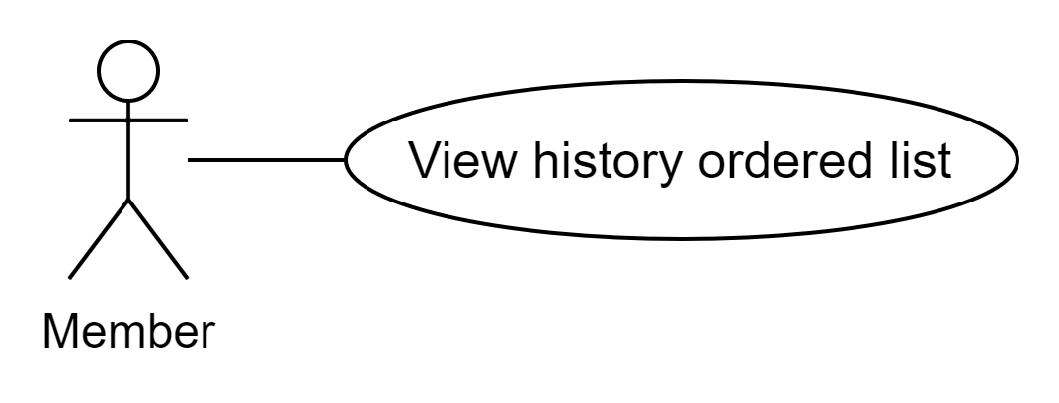

**Brief Description**

The customer log in to the Thegioididong to view history ordered list

**Initial Step-By-Step Description**

1. The system redirects the history order list tab after login success
2. The system allows the customer to perform other activities.

**Use Case:** View profile

**Diagram:**

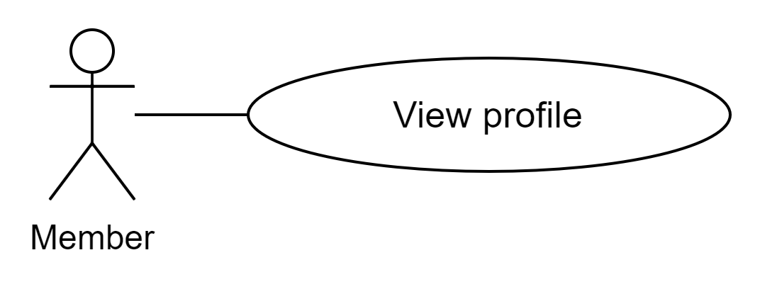

**Brief Description**

The customer log in to the Thegioididong to view profile

**Initial Step-By-Step Description**

1. The customer clicks on the customer information tab in menu bar
2. The system will redirect to that member profile page
3. The system allows the customer to perform other activities.

**Use Case:** Update profile

**Diagram:**

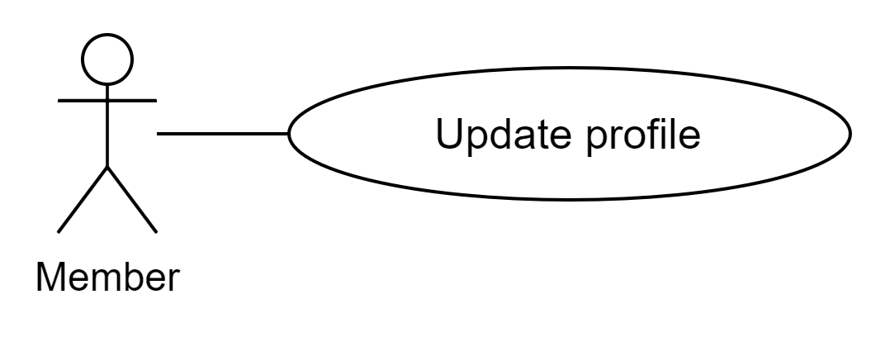

**Brief Description**

The customer log in to the Thegioididong to view profile

**Initial Step-By-Step Description**

1. The customer clicks on the customer information tab in menu bar
2. The system will redirect to that member's profile page.
3. The customer updates their profile and clicks the Save button
4. The system allows the customer to perform other activities.

## ***2.3 User Characteristics***

TBD

## ***2.4 Non-Functional Requirements***

TBD

# **3.0. Requirements Specification**

## ***3.1 External Interface Requirements***

TBD

## ***3.2 Functional Requirements***

The Logical Structure of the Data is contained in Section 3.3.1.

3.2.1 Admin Login

| **Use Case Name** | Admin Login |
| --- | --- |
| **XRef** | Section 2.2.1, Admin Login |
| **Trigger** | The user accesses the login page of Thegioididong website |
| **Precondition** | The login form display |
| **Basic Path** | 1. The admin accesses the login page. 2. The admin fills username/password. 3. The system validates input and response error message if an error happened. 4. The system redirect to add product page if correct username/password. 5. The system allows the user to perform other activities. |
| **Alternative Paths** | None |
| **Postcondition** | None |
| **Exception Paths** | None |
| **Other** | None |

3.2.2 Admin Add New Product

| **Use Case Name** | Admin Add New Product |
| --- | --- |
| **XRef** | Section 2.2.1, Admin Add New Product |
| **Trigger** | The admin accesses the Thegioididong website |
| **Precondition** | None |
| **Basic Path** | 1. The admin accesses to add product page. 2. The admin fills new product information and click add product. 3. The system inserts new product into the database and clear form. 4. The system allows the admin to perform other activities. |
| **Alternative Paths** | None |
| **Postcondition** | None |
| **Exception Paths** | None |
| **Other** | None |

3.2.3 Admin Add New Promotion

| **Use Case Name** | Admin Add New Promotion |
| --- | --- |
| **XRef** | Section 2.2.1, Admin Add New Promotion |
| **Trigger** | The admin accesses the Thegioididong website |
| **Precondition** | None |
| **Basic Path** | 1. The admin accesses to add product page.  2. The admin fills new promotion information and click add promotion.  3. The system insert new promotion to database and clear form.  4. The system allows the admin to perform other activities. |
|  | None |
| **Postcondition** | None |
| **Exception Paths** | None |
| **Other** | None |

3.2.4 Admin View Detail Product

| **Use Case Name** | Admin view detail product |
| --- | --- |
| **XRef** | Section 2.2.1, Admin View Detail Product |
| **Trigger** | The admin accesses the Thegioididong website |
| **Precondition** | None |
| **Basic Path** | 1. The admin accesses to view detail product.  2. The system allows the admin to perform other activities . |
| **Alternative Paths** | None |
| **Postcondition** | None |
| **Exception Paths** | None |
| **Other** | None |

## ***3.3 Detailed Non-Functional Requirements***

### 3.3.1 Logical Structure of the Data

The logical structure of the data to be stored on the system is given below:

**Figure 2 - Logical Structure of the Mobile Store**

### 3.3.2 Security

TBD

### Performance

TBD